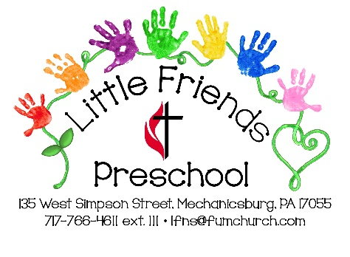
Little Friends Preschool

Date received:___________

Booth #: _______________

Electricity ______________

Table__________________

Craft & Vendor Show
Vendor Registration Form

Saturday, March 7, 2020
Time: 9 a.m. – 1 p.m.

Vendor Name: _____________________________Contact Name:________________________
Address:______________________________________________________________________
City:_____________________________ State _______ Zip:________
Home Phone: ______________________ Cell Phone: __________________________________
E-mail:________________________________________________________________________

Type of business or craft:

______Floral ______Jewelry ______Candles ________Food Items

______Wood ______Beauty ______Kitchen ______Home Décor

______Other

Please provide a brief description of the items you will be selling at the craft show:
__________________________________________________________________________________________________________________________________________________________________________________________________________________________________________

Little Friends Preschool (LITTLE FRIENDS) reserves the right to refuse any vendor application; should this occur the fee will be refunded. The vendor shall hold harmless LITTLE FRIENDS, First United Methodist Church, their respective officers, agents, board members, staff, volunteers and sponsors from any claims, damages, losses, liability or expense which may arise, and shall not be held responsible for any loss or damage due to fire, accident, theft, weather, acts of God, vandalism or any other loss or injury not specifically described.

Please sign to acknowledge that you have read all of the above information, rules and regulations and agree to be bound by the terms of this registration form,.

Signed:_______________________________________________________ Date:________________________________

_____ 8x8 space $35 ______ 8x8 space with electricity $40

Are you willing to donate an item for a raffle? ______

Enclose a check or money order made payable to: LITTLE FRIENDS PRESCHOOL
Return completed form by February 21, 2020 to:
LITTLE FRIENDS at First United Methodist Church
135 W. Simpson St. Mechanicsburg, PA 17055

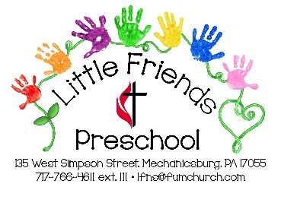
Little Friends Preschool
at First United Methodist Church
135 W. Simpson Street Mechanicsburg, PA 17055
717-766-4611 ext. 111
LFNS@fumchurch.com

Craft & Vendor Show
Saturday, March 7, 2020
Time: 9 a.m. – 1 p.m.

Vendor Registration Form

Event Description:

Vendors providing craft and direct sales items, raffle & food throughout the day. The craft show will be held inside The First United Methodist Church located at 135 W. Simpson St. Mechanicsburg, PA 17055.

Craft Show Information and Requirements: Please read carefully.

- Booth space fees: 8’ x 8’ without electricity $35; with electricity $40. Payment is due with the registration form. Return the completed registration form by February 21, 2020.
- Booth space with access to electric outlets is limited and is available on a first-come, first-serve basis. Vendors must provide their own extension cords.
- All vendor location requests will be considered on a first-come, first-serve basis and honored whenever possible.
- Vendor booths are required to remain open for the entire time the event is operating.
- Provide a detailed description of your booth items on the attached form (add an additional sheet if necessary). Items with inappropriate or offensive themes, as determined by LITTLE FRIENDS or church staff, will be prohibited.
- Vendors can set up their space on Saturday, March 7th between 7 – 9 am. Vendors must be completely set up and checked in by 9 am on March 7th.
- Vendors will have from 1-2:30 to pack up Saturday afternoon. All vendors must be off of church property by 3:00 p.m. the day of the event.
- The vendor is responsible for leaving the vendor area in the condition that it was originally received; all debris such as boxes and trash must be removed.
- Each applicant will receive a confirmation letter upon receipt of their registration form and payment. A copy of the floor plan and directions will be mailed prior to the event.
- Once the application has been accepted all vendor fees are non-refundable.
- In the event of a snowstorm, the event may be cancelled or rescheduled. Vendors will be notified of any changes and the total vendor fee will be refunded if the event is cancelled.
- No alcoholic beverages are permitted on the premises.
- Loud music, broadcasting or amplification is not permitted.
- Items displaying inappropriate words, graphics or tone are not permitted.
- Vendors are responsible for maintaining their area and keeping it clean and clear of trash. The removal of all personal property, equipment, craft items, decorations and accessories is the responsibility of the vendor by the close of the Craft Show.
- No food sales aside from the church are permitted as LITTLE FRIENDS will provide luncheon items and a bake sale during the event.
- We will only allow one vendor per company/organization to participate to alleviate any competition among our sales people. In other words, once a space is reserved by a particular salesperson of any given company, we will prohibit another salesperson from that company to set up.
- Vendors are permitted to sell products directly, take orders, book shows, and hold “free” drawings; however, no raffles are permitted that involve the exchange of money.
- Deadline to submit an application is February 21, 2020.
- Questions regarding the Craft Show may be directed to Maria Petrilak at LFNS@fumchurch.com
- Proceeds from the booth rental benefits Little Friends Preschool.

